Project Design Phase-II
Technology Stack (Architecture & Stack)

Date | 30 September 2026
Team ID | SWTID-2026-7693
Project Name | AI – FAQ ASSISTANT
Maximum Marks | 4 Marks

Technical Architecture :

The AI FAQ Assistant uses a simple layered architecture:
- User Interface: Users ask questions through the application.
- AI Processing: The system understands the user’s question using AI/NLP.
- FAQ Database: Stores frequently asked questions and their answers.
- Response Generation: The system finds the relevant information and generates a clear answer.
- Admin Module: Admin can add, update, or delete FAQ information.
- Database: Stores user queries, FAQ data, and system information securely.

Example: Order processing during pandemics for offline mode

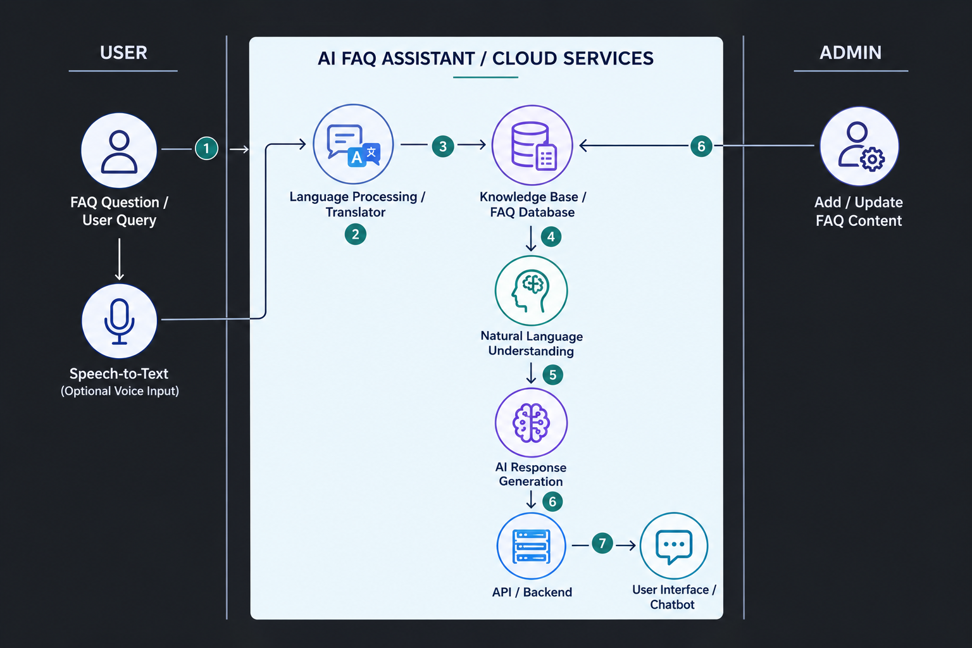

Table-1 : Components & Technologies:

S.No | Component | Description | Technology
 | User Interface | Interface through which users ask questions and receive FAQ answers | HTML, CSS, JavaScript / React.js
 | Application Logic-1 | Handles user requests, FAQ processing and application workflow | Python / Flask
 | Application Logic-2 | Understands user questions using Natural Language Processing | NLP / Python
 | Application Logic-3 | Generates relevant answers from the FAQ knowledge base | AI/LLM / RAG
 | Database | Stores FAQ questions, answers, user data and configurations | MySQL / MongoDB
 | Cloud Database | Stores FAQ and application data on the cloud | MongoDB Atlas / IBM Cloudant
 | File Storage | Stores FAQ documents, PDFs and other knowledge-base files | Local File System / Cloud Object Storage
 | External API-1 | API used for AI-based question answering | OpenAI API / IBM watsonx API
 | External API-2 | API used for additional application services | REST API / Authentication API.
 | Machine Learning Model | Understands user queries and retrieves/generates appropriate FAQ answers | LLM / NLP Model / Sentence Transformers.
 | Infrastructure (Server / Cloud) | Hosts and deploys the AI FAQ Assistant application | Local Server / IBM Cloud / AWS / Docker

Table-2: Application Characteristics:
S.No | Characteristics | Description | Technology
 | Open-Source Frameworks | List the open-source frameworks used to develop the application | Python, Flask, React.js, LangChain
 | Security Implementations | Security and access controls used to protect user data and application resources | HTTPS, Password Hashing, JWT Authentication, Input Validation
 | Scalable Architecture | Architecture designed to handle increasing users and FAQ requests efficiently | 3-Tier Architecture, REST API, Docker
 | Availability | Ensures the AI FAQ Assistant remains accessible and available to users | Cloud Hosting, Load Balancing, Backup & Recovery
 | Performance | Improves response time and handles multiple FAQ requests efficiently | Caching, Database Indexing, API Optimization

